Database Design and Implementation (2026 MOD002589 TRI1 F01CIN)
Student id: 2517671

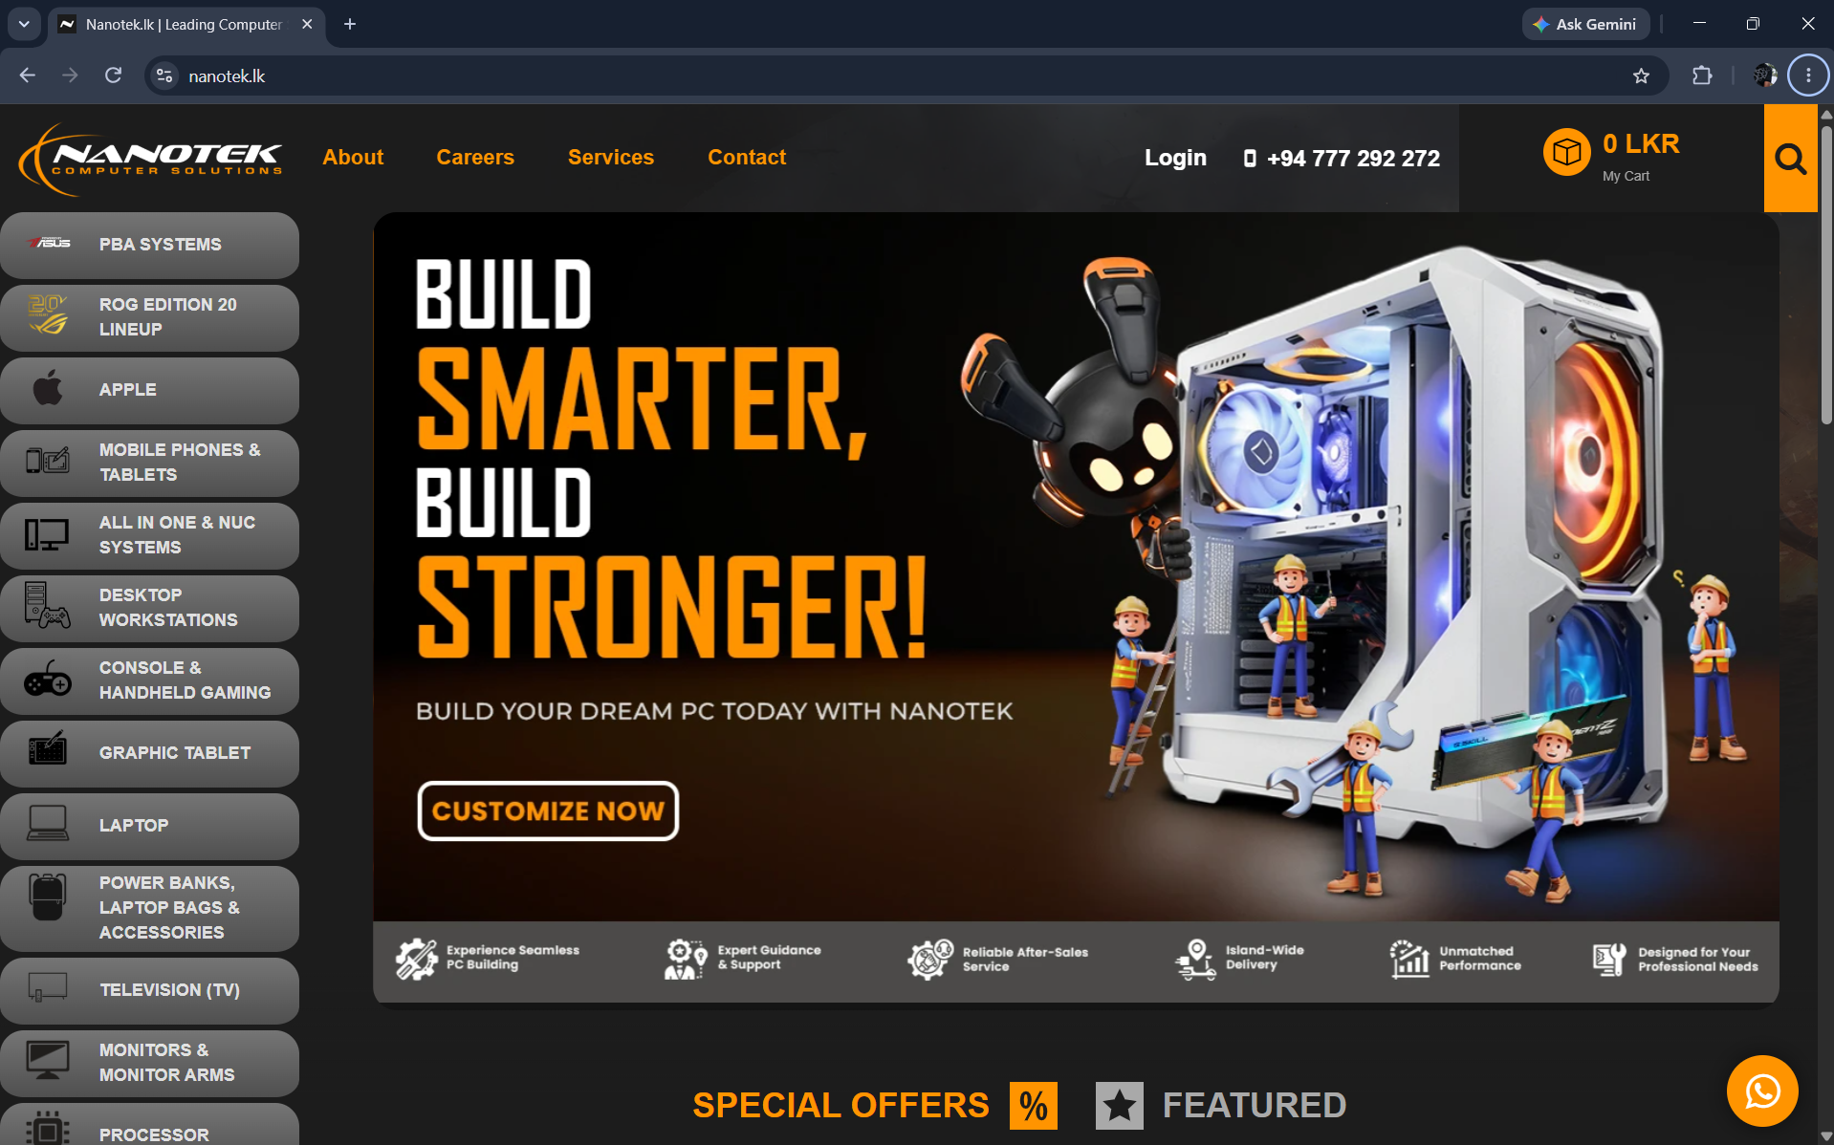

Navbar – Logo , about us, careers , services , contact, login , search
Main image
Category tabs
Social media links

Element | Tag
Title of the website | <Title>
Navigation bar | <nav>
Logo | <img>
Description / text | <p>
Page header | <head>
links | <a>
Website Name | <h1>
Buttons | <button>

